# Writing a Sequential File

This program requests payroll information from the user and writes the information into a text file.

# Positive Testing:

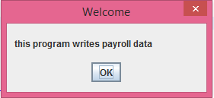

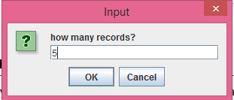

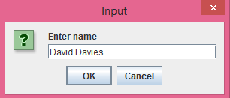

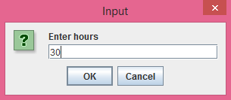

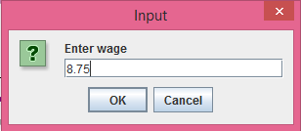

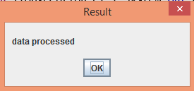

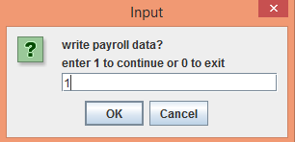

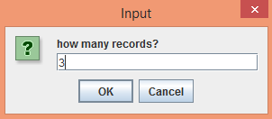

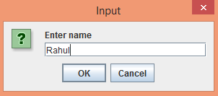



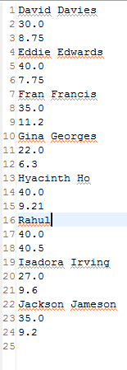

# Negative Testing:

## Entering a string value in number of records:

This will check the Ok and Cancel button and if a user will not enter a number it will again and again ask for the value. If user will not enter any value and press ok, still it will ask user to re-enter the value.

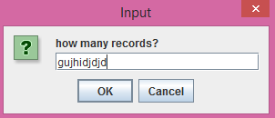

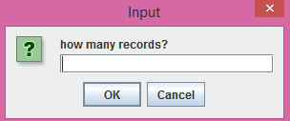

## Enter a Negative value for ‘Number of records’

If user enters a negative value, it will take absolute value of the number of records

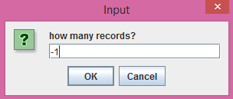

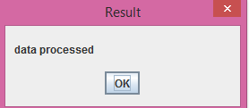

## If number of hours are not entered as a number:

If user enters a string for number of hours, it will run in a loop until the user will enter a valid number.

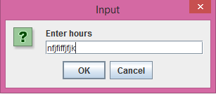

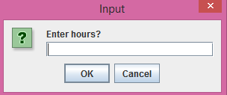

## If user enters a negative value of a number of hours:

The program will take absolute value of the number of hours

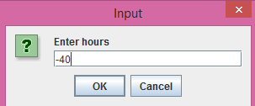

## if user enters a negative value in wage:

The program will take absolute value of the wage

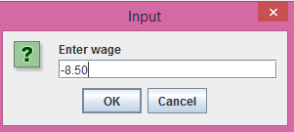

# Code Snippet:

## createdata.java

/**

* Name: Rahul Mittal

* Lab Name: ITMD_510_LAB_04

* Current Date: 10/10/2015

*/

**/\*\***

**\* Name: Rahul Mittal**

**\* Lab Name: ITMD_510_LAB_05**

**\* Current Date: 10/24/2015**

**\*/**

**import java.io.BufferedWriter;**

**import java.io.File;**

**import java.io.FileWriter;**

**import java.io.IOException;**

**import javax.swing.JOptionPane;**

**public class CreateData {**

**public static void main(String[] args)**

**{**

**JOptionPane.showMessageDialog(null,**

**"this program writes payroll data",**

**"Welcome", JOptionPane.PLAIN_MESSAGE );**

**int repeat = 1;**

**String answer;**

**do**

**{**

**Write();**

**answer = JOptionPane.showInputDialog("write payroll data?\n"**

**+ "enter 1 to continue or 0 to exit");**

**repeat = Integer.parseInt(answer);**

**}while(repeat == 1);**

**}**

**/\***

**\* Method to write the data into the file**

**\* This method validate each and every value and**

**\* convert every string value to either integer,double**

**\* and again convert it to String to write it in a file**

**\*/**

**static void Write()**

**{**

**try {**

**String firstLine = "",**

**secondLine = "",**

**thirdLine = "",**

**number = "";**

**Double hours = 0.0,**

**wage = 0.0;**

**File check = new File("payroll.txt");**

**FileWriter file;**

**if(check.exists())**

**//allows appending of data to file**

**file = new FileWriter("payroll.txt", true);**

**else**

**file = new FileWriter("payroll.txt");**

**BufferedWriter buffer = new BufferedWriter(file);**

**int size = 0, count = 1;**

**number = JOptionPane.showInputDialog(null,"how many records?");**

**//Check for null and blank value of number of records**

**if(number == null)**

**{**

**System.exit(0);**

**}**

**else if( number.equalsIgnoreCase(""));**

**{**

**while(number.equalsIgnoreCase(""))**

**{**

**number = JOptionPane.showInputDialog(null,"how many records?");**

**if(number == null)**

**{**

**System.exit(0);**

**}**

**}**

**}**

**//Check for string value in number of records**

**String errorMessage = "";**

**do**

**{**

**try**

**{**

**size = Math.abs(Integer.parseInt(number));**

**break;**

**}**

**catch(NumberFormatException e)**

**{**

**number = JOptionPane.showInputDialog(null,"how many records?");**

**if(number == null)**

**{**

**System.exit(0);**

**}**

**errorMessage = "Error";**

**}**

**}while (!errorMessage.isEmpty());**

**// Check for null and blank value for name**

**do**

**{**

**firstLine = JOptionPane.showInputDialog(null,"Enter name");**

**if(firstLine == null)**

**{**

**System.exit(0);**

**}**

**else if( firstLine.equalsIgnoreCase(""));**

**{**

**while(firstLine.equalsIgnoreCase(""))**

**{**

**firstLine = JOptionPane.showInputDialog(null,"Enter name");**

**if(firstLine == null)**

**{**

**System.exit(0);**

**}**

**}**

**}**

**//Check for null value of hours**

**secondLine = JOptionPane.showInputDialog(null,"Enter hours");**

**if(secondLine == null)**

**{**

**System.exit(0);**

**}**

**else if( secondLine.equalsIgnoreCase(""));**

**{**

**while(secondLine.equalsIgnoreCase(""))**

**{**

**secondLine = JOptionPane.showInputDialog(null,"Enter hours");**

**if(secondLine == null)**

**{**

**System.exit(0);**

**}**

**}**

**}**

**//Check for string value in number of hours**

**do**

**{**

**try**

**{**

**hours = Math.abs(Double.parseDouble(secondLine));**

**break;**

**}**

**catch(NumberFormatException e)**

**{**

**secondLine = JOptionPane.showInputDialog(null,"Enter hours?");**

**if(secondLine == null)**

**{**

**System.exit(0);**

**}**

**errorMessage = "Error";**

**}**

**}while (!errorMessage.isEmpty());**

**//convert double to string for writing the data to file**

**String hours_string = Double.toString(hours);**

**//Check for null and blank value for wage**

**thirdLine = JOptionPane.showInputDialog(null,"Enter wage");**

**if(thirdLine == null)**

**{**

**System.exit(0);**

**}**

**else if( thirdLine.equalsIgnoreCase(""));**

**{**

**while(thirdLine.equalsIgnoreCase(""))**

**{**

**thirdLine = JOptionPane.showInputDialog(null,"Enter wage");**

**if(thirdLine == null)**

**{**

**System.exit(0);**

**}**

**}**

**}**

**//check for string value in wage**

**do**

**{**

**try{**

**wage = Math.abs(Double.parseDouble(thirdLine));**

**}**

**catch(NumberFormatException e)**

**{**

**thirdLine = JOptionPane.showInputDialog(null,"Enter wage");**

**if(thirdLine == null)**

**{**

**System.exit(0);**

**}**

**errorMessage = "Error";**

**}**

**} while(!errorMessage.isEmpty());**

**//convert to string value for writing it to file**

**String wage_string = Double.toString(wage);**

**//write all the data to file**

**buffer.write(firstLine);**

**buffer.newLine();**

**buffer.write(hours_string);**

**buffer.newLine();**

**buffer.write(wage_string);**

**buffer.newLine();**

**count++;**

**firstLine = null;**

**secondLine = null;**

**thirdLine = null;**

**}while(count <= size);**

**buffer.close();**

**JOptionPane.showMessageDialog(null, "data processed",**

**"Result", JOptionPane.PLAIN_MESSAGE );**

**}**

**catch (IOException e) { System.out.println(e); }**

**}**

**}**